Concept & target
infinite Exceptions
Inspiration: smart home products Amazon Alexa
Homatic IP "Automation" infinite "Exception Manager"
Possible actions at Entry & Exit Use-cases
Use-case 1: Tolerate expired contract parker at exit for low amount Use-case 2: Tolerate not paid with low amount at exit during night Use-case 3: Manage wrong presence at entry & exit
Use-case 4: Car access - medium not found Use-case 5: Counter full
Use-case 5: entry out of access profile
Use-case 6: Customer can not pay at paystation Meeting notes 05.02.2025
As a car park operator, I would like to like to manage the exceptions in a flexible way based on definable rules, so that I can view and adapt these according to my needs for my car parks.

Concept & target
Prepare a common understanding of more efficient, convenient exception handling in future, i.e. define more flexible work-flows with rules, conditions and actions
Idea: Exceptions and resulting actions are pre-defined with defaults but the decision engine is flexible and can be adapted to contribute to autonomous parking operations
This goes into a simillar direction as the paramter "Strict mode", refer to https://fcs-conflu-01.ads.local/x/WaZAF which can also be sees as "exceptions".

infinite Exceptions
https://fcs-conflu-01.ads.local/x/XnoEF https://fcs-conflu-01.ads.local/x/mlUEF

Inspiration: smart home products

Amazon Alexa
Idea could be to follow smart home products

- Add a new routine
- Define a routine name
- Select "Condition(s)"
- Select "Action" Amazon Alexa "Routine"
New Routine → Wenn → Alexa will →

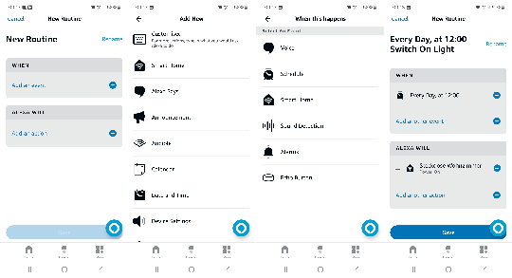

Homatic IP "Automation"
New automation → Trigger → Additional condition → Action
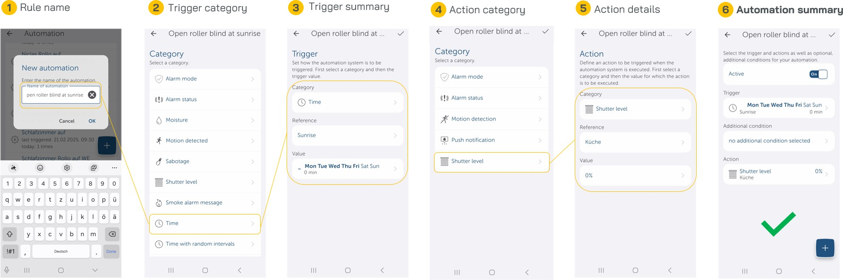

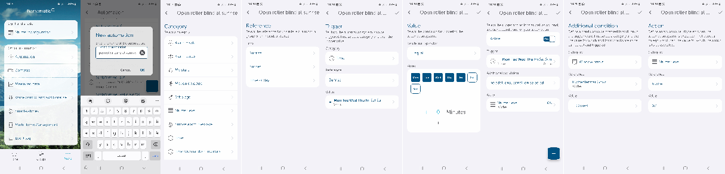
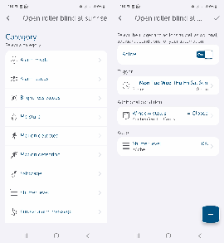

infinite "Exception Manager"
new application entervo infinite "Exception Manager" to manage all exceptions
infinite provides various pre-configured exception handling profiles including rules defined by S&B e.g.
Commercial Parking #1 - No hassle "autonomous" Commercial Parking #2 - Balanced
Commercial Parking #3 - Protect revenue Car Access: secure car park access
Pre-configured rules are visualized in a transparent overview e.g. operator can follow which arctions will result Profiles, rules (conditions & Actions) are customizable by operator
Switching of profiles based on week profile e.g. during business hours "Protect revenue", out of business hours "No hassle "autonomous" Car park can be selected (in case not applicable to all car parks of tenant)
Exception routines can be activate or deactivated Each exception can have multiple rules assigned
Rule IDs must be changable in priorisation (up or down)

Possible actions at Entry & Exit
Note: Conditions and actions are just an initial draft list and to be extended!!

Exception name e.g. defined by infinite default or customer | Device type | Rule active | Product Condition | Condition (one or multiple) and/or | Action (multiple selection with sequence)
- Wrong presence at entry & exit  - Car park occupied /full  - Ignore counter for certain customer groups  - Ignore counter for certain products  - Registered Customer - wrong LPN at entry  - Fuzzy LPN: N-1  - New customer - delivery service, taxi  - Contract parker expired at entry  - Contract parker expired at exit  - Contract blocked/inactive  - Consumer blocking  - Short-term parker cannot pay at pay station and SWP  - Contract parker at exit with short-term parker product  - Short-term Parker with no payment at exit  - Visit not yet valid or expired at entry & exit  - ... | Entry Exit APS  Door | Yes/No | - Produc t  group  - Produc t name | - Based on amount <= €  - Based on duration <= hh:mm  - Day/ time scheduler e.g. Only on weekends or from 19: 00-6:00 (also available in overall exception handling profile)  - Weekprofile (also available in overall exception handling profile)  - Validity periode e.g. 1.1.2026-1.3.2026  - Additional payment required  - Expired product  - Invalid contract  - Expired contract  - Location e.g. car park  - Facility name  - Device name  - Wrong presence  - Customer not allowed for location/facility  - Car park occupied /full  - Product full  - Fuzzy match  - Blocked/ Inactive  - No payment possible e.g. POFs are out of service  - Not valid yet  - Device offline e.g. no authorisation possible  - Intercom not working  - Duration since last entry >= hh:mm  - Duration since last exit >= hh:mm  - Duration since last payment >= hh:mm  - Percentage of exceeded paid time  - ... | - No system action - Silent  - System notification (global notification)  - System notification for response (exception widget)  - Trigger automated intercom call  - Open barrier  - Book amount as lost revenue  - Book open amount for later payment e.  g. invoicing  - Book open amount for direct payment  - Timer x seconds  - Ignore counter blocking  - Proceed with regular handling  - Create virtual transaction with curent time (-1s)  - Create virtual transaction with actual time - hh:mm (e.g. - 1 hour → Tariff will apply)  - Create virtual transaction with time stamp from last trasnaction (+1s)  - ...

Use-cases

Use-case 1: Tolerate expired

contract parker at exit for low amount

Contract parker expired at exit (also overstay), requires local payment. Depending on amount the decision will vary: Under 2 € open barrier
2-10 € Invoice amount for a possible claim but open barrier >10 € Claim direct payment e.g. show fee at device

Exception name | Device type | Exception Rule ID | Product Condition | Condition (one or multiple) and/or | Action (multiple selection with sequence)

9. Contract parker expired at exit | Exit | 1 | Product group: Contract parker | Based on amount <= 10 € AND  Expired product | Condition true:  1. No system action - Silent (Go to next condition)  Condition false:  7. Book open amount for direct payment
9. Contract parker expired at exit | Exit | 2 | Product group: Contract parker | Based on amount <= 2 € AND  Expired product | Condition true:  5. Book amount as lost revenue  4. Open barrier Condition false:  6. Book open amount for later payment e.g. invoicing  4. Open barrier

Use-case 2: Tolerate not paid with low amount at exit during night
Short term parker with low payment amount e.g. max 1 € will be tolerated at exit during the night (19:00-06:00)
If amount >1 € (configurable) then usual behavior

Exception name | Device type | Exception Rule ID | Product Condition | Condition (one or multiple) and/or | Action (multiple selection with sequence)
Low amount due at exit during night will be tolerated (similar to 14.) | Exit | 1 | Product group: All | Based on amount <= 1 €  AND | Condition true:  5. Book amount as lost revenue
 |  |  |  | Day/ time scheduler daily 19:00-6:00 | 4. Open barrier  Condition false:
 |  |  |  |  | 3. Trigger automtated intercom call
 |  |  |  |  | 7. Book open amount for direct payment

update to general rules

Exception name | Device type | Exception Rule ID | Product Condition | Condition (one or multiple) and  /or | Action (multiple selection with sequence)
Tolerate not paid at exit | Exit | 1 | Product group: any | Exception must be handled by operator | Condition true:  stop the customer, fire exception
 |  |  |  |  | Condition false:
 |  |  |  |  | Proceed with next rule ID 2
 |  | 2 | Product group: Registered | Autohandling of exception AND valid contract  AND  not paid amount < 6 EUR AND payment type ANY (on invoice or locally) | Condition true:  - open the barrier  - Book exit trx with exceptional product, so the price in journal will be 0 EUR
 |  |  |  |  | Condition false:
 |  |  |  |  | Proceed with next rule ID 2

 |  | 3 | Product group: Short term | not paid amount < 5 EUR AND  honest payment with fuzzy n-2 not found | Condition true:  - Book amount as lost revenue  - Open barrier
 |  |  |  |  | Condition false:
 |  |  |  |  | Proceed with next rule ID 4
 |  | 4 | Product group: Short term | Honest payment with fuzzy n-2 found  AND  No other present car with fuzzy n- 2 exist | Condition true:  - match the honest payment to the parking transaction 2 open the barrier. Proceed with regular handling
 |  |  |  |  | Condition false:
 |  |  |  |  | Proceed with next rule ID 5
 |  | 5 | Product group: Short term | price > 5 EUR | Condition true:  1stop the customer
 |  |  |  |  | 2. fire an not paid exception
 |  |  |  |  | 3. Proceed with regular exception hadnlinghandling

Use-case 3: Manage wrong presence at entry & exit
Wrong presence at entry & exit

Exception name | Device type | Exception Rule ID | Product Condition | Condition (one or multiple) and/or | Action (multiple selection with sequence)
Tolerate wrong presence at entry | Entry | 1 | Product group: Employee | Wrong presence AND  Duration since last entry  >= 24:00 | Condition true:  13.Create virtual transaction with time stamp from last trasnaction (+1s)  2.System notification only (show in exception widget & trigger global notification)  11.Proceed with regular handling Condition false:  Proceed with next rule ID 2
Tolerate wrong presence at entry | Entry | 2 | Product group: Employee | Wrong presence | Condition true:  2.System notification only (show in exception widget & trigger global notification)  4. Trigger automtated intercom call Condition false:  Proceed with next rule ID 3
Tolerate wrong presence at entry | Entry | 3 | Product group: Short term | Wrong presence | Condition true:  10.Close previous open transaction  11.Proceed with regular handling
Tolerate wrong presence at exit | Exit | 1 | Product group: All | Wrong presence | Condition true:  12. Create virtual transaction (in this case an entry transaction)  2.System notification only (show in exception widget & trigger global notification)  11.Proceed with regular handling

Use-case 4: Car access - medium not found
should we consider as well time interval by the rules? valid in January, valid from - to? Yes a TIME INTERVALL is required, open the barrier should be a short-term parker or in car access an ad-hoc parker

Exception name | Device type | Exception Rule ID | Product Condition | Condition (one or multiple) and  /or | Action (multiple selection with sequence)
Unknown LPN on entry  car access only | Entry | 1 | Product group: none | Exception must be handled by operator | Condition true:  stop the customer, fire exception Condition false:  Proceed with next rule ID 2
Unknown LPN on entry  car access only | Entry | 2 | Product group: none | Auto handling of exception AND  fuzzy deactivated OR fuzzy activated AND  no fuzzy candidate found | Condition true:  - open the barrier  - Book showup product with the lpn Condition false:  Proceed with next rule ID 3
Unknown LPN on entry  car access only | Entry | 3 | Product group: none | Auto handling of exception AND  fuzzy activated AND  found fuzzy candidate | Condition true:  - open the barrier  - Book registered customer entry with original and fuzzy LPN

Use-case 5: Counter full

Exception name | Device type | Exception Rule ID | Product Condition | Condition (one or multiple) and/or | Action (multiple selection with sequence)
related counter full | Entry | 1 | Product group counter: ANY | Exception must be handled by operator | Condition true:  stop the customer, fire exception
 |  |  |  |  | Condition false:
 |  |  |  |  | Proceed with next rule ID 2
 |  | 2 | Product group counter: ANY | Auto handling of exception AND  related counter FULL AND  related counter mode = NORMAL | Condition true:  - open the barrier  - overbook the counter
 |  |  |  |  | Condition false:
 |  |  |  |  | Proceed with next rule ID 3
 |  | 3 | Product group counter: ANY | Auto handling of exception AND  related counter FREE AND  car park is FULL | Condition true:  stop the customer, fire exception Condition false:
 |  |  |  |  | Proceed with next rule ID 3
 |  | 4 | Product group counter: ANY | Auto handling of exception  AND  related counter BLOCKED | Condition true:  stop the customer, fire exception

Use-case 5: entry out of access profile

Exception name | Device type | Exception Rule ID | Product Condition | Condition (one or multiple) and  /or | Action (multiple selection with sequence)
entry out of access profile | Entry | 1 | Product group counter: ANY | Exception must be handled by operator | Condition true:  stop the customer, fire exception
car access only |  |  |  |  | Condition false:
 |  |  |  |  | Proceed with next rule ID 2
 |  | 2 | Product group counter: ANY | Auto handling of exception AND  product entry grace time violated | Condition true:  1.open the barrier
 |  |  |  |  | 2. book entry with out of access profile product
 |  |  |  |  | Condition false:
 |  |  |  |  | Proceed with next rule ID 3
 |  | 3
 |  | 4

Use-case 6: Customer can not pay at paystation

Exception name | Device type | Exception Rule ID | Product Condition | Condition (one or multiple) and/or | Action (multiple selection with sequence)
 |  | 1
 |  | 2
 |  | 3

Visitor too early |  |  |  | Grace time configured in PAM can help

Visitor too late

Visitor at wrong facility
Flex parker without booking

Meeting notes 05.02.2025
Central exception management that applies to all business use cases: Open barrier
Structure: flexibel flow, rules & conditions like smart home programming (commonly understandable) Default sets of standard exception flows (groups) with kits of conditions an d actions
Time2Market is important
Isolate use cases of exceptions for start ( new and at least one existing to compare/see benefits) Differentiate car access and commercial parking (regular & autonomous)
Concept / Impact mapping in PI#17, start with PI#18 Need to be aligned to infinite DNA
Aggregated conditions3

